Physical-to-Virtual (P2V) Migration

🌟 Definition
# Source: AI Source: Provided by: [Data Path: Persons Table -> ID Column: 1, Name_En Column: Motasem Essam] -> From: [ChatGPT] on [6/7/2026]
Physical-to-Virtual (P2V) Migration is the process of converting a physical server into a virtual machine (VM) and moving its applications, operating system, data, and configurations into a virtualized environment.
Instead of running directly on hardware, the server runs as a VM on a virtualization platform.

🎯 Purpose
# Source: AI Source: Provided by: [Data Path: Persons Table -> ID Column: 1, Name_En Column: Motasem Essam] -> From: [ChatGPT] on [6/7/2026]
Organizations perform P2V migration to:
- Reduce hardware costs
- Consolidate servers
- Improve resource utilization
- Simplify management
- Improve backup and recovery
- Prepare for cloud migration

🧠 Simple Definition
# Source: AI Source: Provided by: [Data Path: Persons Table -> ID Column: 1, Name_En Column: Motasem Essam] -> From: [ChatGPT] on [6/7/2026]
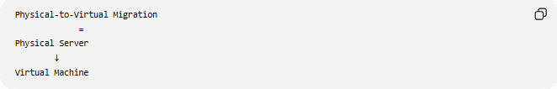
Physical-to-Virtual Migration
=
Physical Server
↓
Virtual Machine

📚 What is a Virtual Machine?
# Source: AI Source: Provided by: [Data Path: Persons Table -> ID Column: 1, Name_En Column: Motasem Essam] -> From: [ChatGPT] on [6/7/2026]
A Virtual Machine (VM) is a software-based computer (Computer software) that behaves like a physical server.
A VM has:
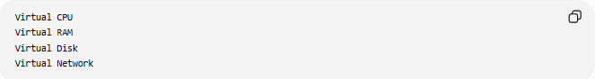
Virtual CPU
Virtual RAM
Virtual Disk
Virtual Network
but runs on shared physical hardware.

🔍 P2V Migration Overview
# Source: AI Source: Provided by: [Data Path: Persons Table -> ID Column: 1, Name_En Column: Motasem Essam] -> From: [ChatGPT] on [6/7/2026]
Before
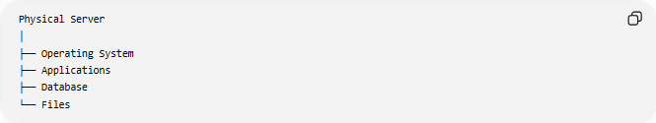
Physical Server
│
├── Operating System
├── Applications
├── Database
└── Files

After
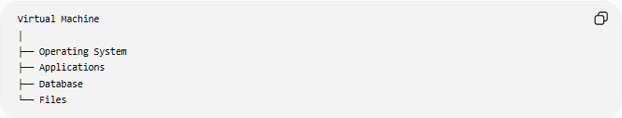
Virtual Machine
│
├── Operating System
├── Applications
├── Database
└── Files
Everything is preserved but runs virtually.

🏗️ Why Companies Use P2V
# Source: AI Source: Provided by: [Data Path: Persons Table -> ID Column: 1, Name_En Column: Motasem Essam] -> From: [ChatGPT] on [6/7/2026]
Before
Many physical servers:
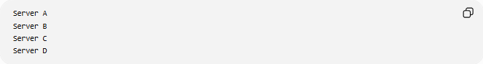
Server A
Server B
Server C
Server D

Each server may use only:
10% - 20% CPU

After
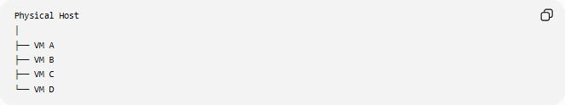
Physical Host
│
├── VM A
├── VM B
├── VM C
└── VM D

Benefits:
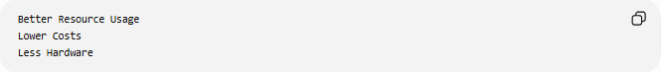
Better Resource Usage
Lower Costs
Less Hardware

🛠️ Real-World Example
# Source: AI Source: Provided by: [Data Path: Persons Table -> ID Column: 1, Name_En Column: Motasem Essam] -> From: [ChatGPT] on [6/7/2026]
Before Migration
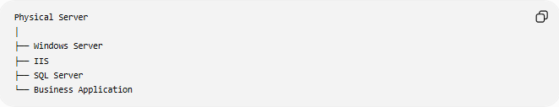
Physical Server
│
├── Windows Server
├── IIS
├── SQL Server
└── Business Application

Problems:
Aging Hardware
High Maintenance Cost

Migration
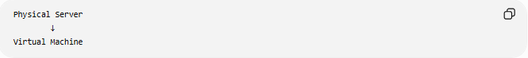
Physical Server
↓
Virtual Machine

After Migration
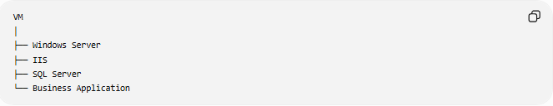
VM
│
├── Windows Server
├── IIS
├── SQL Server
└── Business Application
Runs on a virtualization host.

🔄 Migration Lifecycle
# Source: AI Source: Provided by: [Data Path: Persons Table -> ID Column: 1, Name_En Column: Motasem Essam] -> From: [ChatGPT] on [6/7/2026]
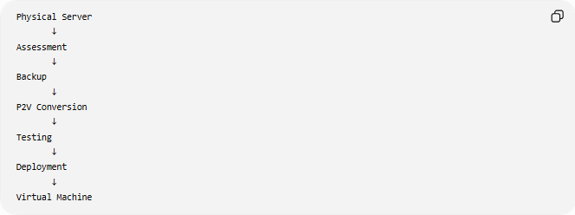
Physical Server
↓
Assessment
↓
Backup
↓
P2V Conversion
↓
Testing
↓
Deployment
↓
Virtual Machine

📦 What Gets Migrated?
# Source: AI Source: Provided by: [Data Path: Persons Table -> ID Column: 1, Name_En Column: Motasem Essam] -> From: [ChatGPT] on [6/7/2026]
Operating System
Examples:
- Microsoft Windows
- Linux

Applications
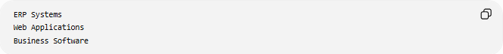
ERP Systems
Web Applications
Business Software

Databases
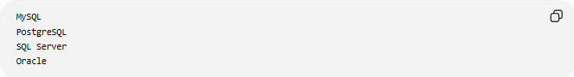
MySQL
PostgreSQL
SQL Server
Oracle

Files
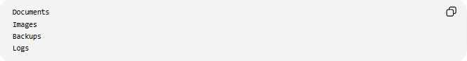
Documents
Images
Backups
Logs

Configurations
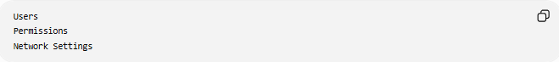
Users
Permissions
Network Settings

🌍 Example Infrastructure
# Source: AI Source: Provided by: [Data Path: Persons Table -> ID Column: 1, Name_En Column: Motasem Essam] -> From: [ChatGPT] on [6/7/2026]
Before
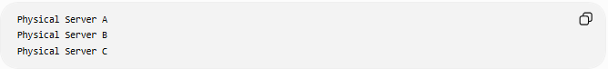
Physical Server A
Physical Server B
Physical Server C

After
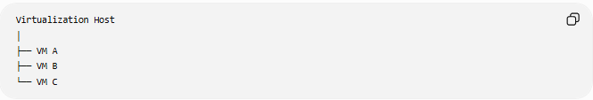
Virtualization Host
│
├── VM A
├── VM B
└── VM C

Hardware usage becomes more efficient.

🏢 Popular Virtualization Platforms
# Source: AI Source: Provided by: [Data Path: Persons Table -> ID Column: 1, Name_En Column: Motasem Essam] -> From: [ChatGPT] on [6/7/2026]
Common platforms:
- VMware vSphere
- Microsoft Hyper-V
- KVM
- Oracle VM VirtualBox

⚠️ Common Challenges
# Source: AI Source: Provided by: [Data Path: Persons Table -> ID Column: 1, Name_En Column: Motasem Essam] -> From: [ChatGPT] on [6/7/2026]
Hardware Drivers
Physical hardware drivers may not work inside a VM.

Performance Tuning
Virtual resources must be properly allocated.
Example:
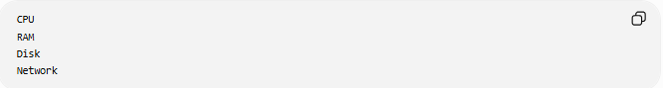
CPU
RAM
Disk
Network

Large Data Transfers
Servers containing:
TBs of Data
may require long migration times.

Downtime
Some migrations require:
Maintenance Windows

Licensing
Software licenses may need updates after virtualization.

✅ Benefits
# Source: AI Source: Provided by: [Data Path: Persons Table -> ID Column: 1, Name_En Column: Motasem Essam] -> From: [ChatGPT] on [6/7/2026]
Lower Hardware Costs
Fewer Physical Servers

Better Resource Utilization
Higher CPU Usage
Better Memory Usage

Easier Backups
VMs can often be backed up as complete images.

Faster Recovery
Restore Entire VM
instead of rebuilding a physical server.

Simplified Management
Multiple VMs can be managed from one platform.

Cloud Readiness
VMs are easier to move to cloud environments.

📊 Physical-to-Virtual vs Physical-to-Physical
# Source: AI Source: Provided by: [Data Path: Persons Table -> ID Column: 1, Name_En Column: Motasem Essam] -> From: [ChatGPT] on [6/7/2026]
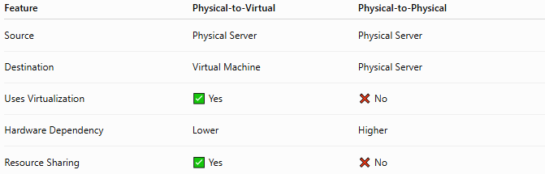
Feature | Physical-to-Virtual | Physical-to-Physical
Source | Physical Server | Physical Server
Destination | Virtual Machine | Physical Server
Uses Virtualization | ✅ Yes | ❌ No
Hardware Dependency | Lower | Higher
Resource Sharing | ✅ Yes | ❌ No

Physical-to-Virtual
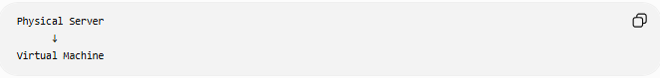
Physical Server
↓
Virtual Machine

Physical-to-Physical
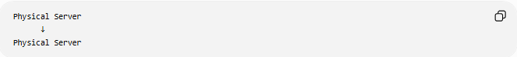
Physical Server
↓
Physical Server

🛠️ Common P2V Migration Tools
# Source: AI Source: Provided by: [Data Path: Persons Table -> ID Column: 1, Name_En Column: Motasem Essam] -> From: [ChatGPT] on [6/7/2026]
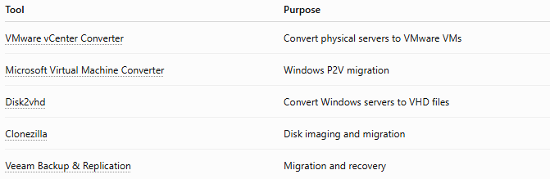
Tool | Purpose
VMware vCenter Converter | Convert physical servers to VMware VMs
Microsoft Virtual Machine Converter | Windows P2V migration
Disk2vhd | Convert Windows servers to VHD files
Clonezilla | Disk imaging and migration
Veeam Backup & Replication | Migration and recovery

🧠 Simple Analogy
# Source: AI Source: Provided by: [Data Path: Persons Table -> ID Column: 1, Name_En Column: Motasem Essam] -> From: [ChatGPT] on [6/7/2026]
Imagine moving from owning a dedicated building to renting office space in a modern business center.
Before
One Building
One Business

After
One Building
Multiple Businesses
Each business still operates independently but shares resources more efficiently.
P2V migration works the same way:
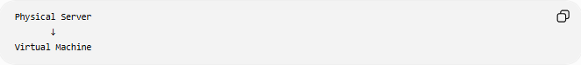
Physical Server
↓
Virtual Machine
while preserving the operating system, applications, and data.

🧭 Summary
# Source: AI Source: Provided by: [Data Path: Persons Table -> ID Column: 1, Name_En Column: Motasem Essam] -> From: [ChatGPT] on [6/7/2026]
Physical-to-Virtual (P2V) Migration is a type of server migration where a physical server is converted into a virtual machine. The operating system, applications, databases, files, and configurations are moved into a virtualized environment running on platforms such as VMware vSphere or Microsoft Hyper-V. The primary benefits are lower hardware costs, better resource utilization, easier management, improved backup and recovery, and readiness for future cloud migrations.

